

INTEGRATED BILLING

TECHNICAL MANUAL /
SECURITY GUIDE

IB Version 2.0

Patch
IB*2.0*433

May 2011

Veterans Affairs
Product Development (PD)

This page included for two-sided copying.)

Revision History
Date | Revision | Description of Change | Author Information
05/04/2011 | Patch IB*2.0*433 | Initial Version | Berry Anderson/ Darlene White

(This page included for two-sided copying.)

PREFACE
This is the Technical Manual for Integrated Billing (IB) patch IB*2.0*433. It is designed to assist IRM personnel in the operation and maintenance of these patches.

For information regarding use of the software, please refer to the EDI User Guide.

For information on the installation of this interface, please refer to the Release Notes and Installation Guides associated with patch IB*2.0*433.

Note to Users with Qume Terminals
It is very important that you set up your Qume terminal properly. After entering your access and verify codes, you will see

Select TERMINAL TYPE NAME: {type} //

Please make sure that <C-QUME> is entered here. This entry will become the default. You can then press <RET> at this prompt for all subsequent logins. If any other terminal type configuration is set, options using the List Manager utility will neither display nor function properly on your terminal. The reports and error messaging system in the interface makes extensive use of the List Manager functions.

Who Should Read this Manual?
This manual is intended for technical IRM personnel who may be called upon to install and support this software.

(This page included for two-sided copying.)
Table of Contents

PREFACE v
Note to Users with Qume Terminals v
Who Should Read this Manual? v
Introduction 1
Implementation and Maintenance 1
General Notes Regarding Changes to this Software 1
Platform Requirements 1
Pre-Requisite Patch Requirements 1
Revenue Process 2
EDI Process Flow 3
Files 4
Namespace 4
File List 4
Input Templates 4
List Templates 5
Protocols 5
Routines 5
Exported Options 5
Archiving 6
Callable Routines/Entry Points/Application Program Interfaces 6
Callable Routine 6
Entry Points 6
External Relationships 6
Internal Relationships 6
Global Variables 7
Security 7
File Protection 7
Security Keys 7
Options Locked by Security Keys 8
Glossary 9

(This page included for two-sided copying.)

Introduction
The ability to allow users to correct rejected or denied claims to third party insurance companies, while maintaining the original claim number has been added to Veterans Health Integrated Systems Technology Architecture (VistA). This is a result from business needs identified by the Chief Business Office (CBO). The ability to resubmit a rejected/denied claim with the original claim number is normal process for most of the industry. This capability will also provide the ability to better track the processing of claims as it provides the means to follow claims through the resubmission process and track the changes that were required as a result of a rejection or denial.

Implementation and Maintenance
There are no new or modified Site Parameters as a result of patch IB*2.0*433. Nor does this patch modify the current process flow at the sites.

General Notes Regarding Changes to this Software

- Integrated Billing files may only be updated through distributed options.
- Per Veterans Health Administration (VHA) Directive 2004-038 regarding security of software that affects financial systems, most of the IB routines and files may not be modified. Routines that may not be modified will be indicated by a comment on the third line. Files that may not be modified will have a note in the file description.
- According to the same directive, most of the IB Data Dictionaries may not be modified.

Platform Requirements

VistA System:
A fully patched and complete VistA system is required, running Integrated Billing (IB) Version 2.0. In particular, the pre-requisite patches listed below must be installed prior to the installation of the EDI patch IB*2.0*433.

In addition, the VistA system must have a properly installed and functioning Health Level Seven (HL7) module.

Pre-Requisite Patch Requirements
VistA Package and Version | Associated Patch Designation(s) | Brief Patch Description
Integrated Billing (2.0) | IB*2.0*347 | Pharmacy encapsulation prescription file 52 & associated file changes
Integrated Billing (2.0) | IB*2.0*358 | eClaims plus issues resolution
Integrated Billing (2.0) | IB*2.0*400 | eClaims additional claim form and transmission data
Integrated Billing (2.0) | IB*2.0*420 | Assignment Benefits Code for TRICARE
Accounts Receivable (4.5) | PRCA*4.5*270 | e-Billing preserve claim number when cloned

Revenue Process
The overall patient billing revenue process for the VHA is summarized in the table below:

Revenue Cycle
Intake | UR | Billing | Collection | UR
Patient Registration  Insurance  Identification  Insurance Verification | Pre-certification & Certification  Continued Stay | Documentation  EDI Bill Generation  MRA  Claim status messages | Establish Receivables  A/R Follow-up  Lockbox  Collection Correspondence | Appeals

During the Intake phase, the patient is registered. Insurance information is identified and/or verified.

In the Utilization Review phase, the patient is pre-certified and certified, and continued stay reviews are performed.

In the Billing phase, the patient encounter is documented and coded. An electronic data interchange (EDI) bill and/or Medicare Remittance Advice (MRA) request is generated and sent to the payer. Claim status messages include information that appears on the Claims Status Awaiting Resolution (CSA) report.

During the Collections phase, establishment of receivables, accounts receivables follow-up, lockbox, and any collection correspondence take place.

Another Utilization Review can take place if there are any appeals.

EDI Billing provides the VHA with the capability to submit electronic Institutional & Professional claims, rather than printing and mailing claims from each facility.

No changes are being made to the Revenue process with the introduction of IB*2.0*433 except that users will now be able to correct rejected or denied claims to third party insurance companies, while maintaining the original claim number. This new ability of correcting a claim while maintaining the original claim number, allows a user to correct a claim as long as no payments have been posted to the claim in Accounts Receivable (AR).

EDI Process Flow

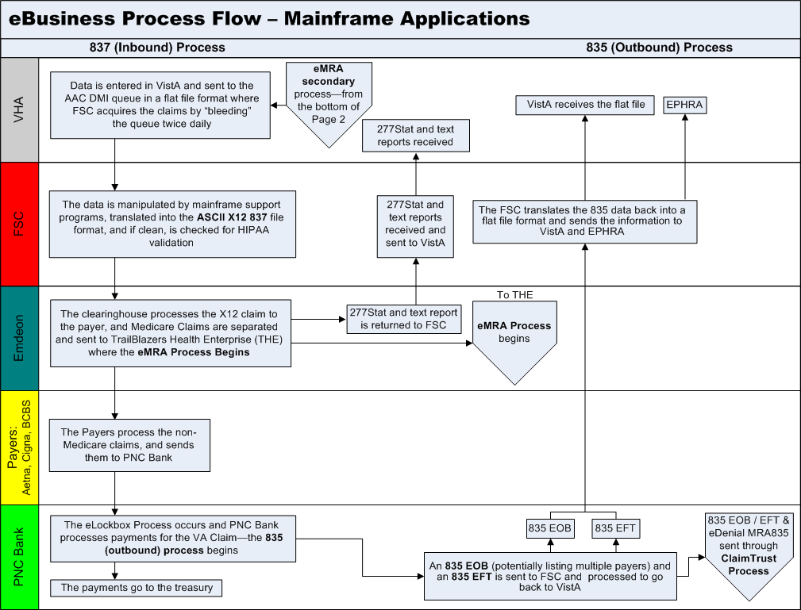

The above flowchart represents the path electronic claims follow. The objective of electronic billing is to submit completely correct claims. Claims sent electronically reach the payer faster, are processed faster, and are paid faster than claims submitted on paper via the mail.

From the user’s desktop, the claim goes to the Financial Service Center (FSC) in Austin, TX as a VistA MailMan message. The FSC translates the claim into the Health Insurance Portability and Accountability Act (HIPAA) 837 format and forwards it to the clearinghouse.

The clearinghouse processes the claims. Medicare claims are separated and sent to TrailBlazers Health Enterprise. Other claims are sent to the Payer. If the clearinghouse does not have an electronic connection with a payer or if specific claims must be submitted on paper, the claim is printed at Express Bill and mailed to the payers.

The payer adjudicates the claim and determines payment. The payment may be sent electronically to PNC Bank as an electronic funds transfer (EFT) or the payer may mail a paper check.
PNC Bank will send: EFT dollars directly to the U.S. Treasury, .EFT 835 transactions, containing daily total deposit information by payer to the FSC, and Electronic Remittance Advice (ERA) 835 transactions, containing electronic EOBs (EEOBs) to the FSC.
The FSC will pass EFT and ERA information on to each VAMC in flat file format via VistA MailMan messages. Additionally, the FSC will transmit the EFT and ERA flat file information to the EEOB and Payment Healthcare Resolution Application (EPHRA) database, maintained by the Austin Information Technology Center (AITC), but managed by the FSC 224-Unit staff. The FSC will also transmit unroutable EEOB data to EPHRA. Unroutable EEOB data does not contain the appropriate Tax ID information to allow the FSC to route it to the proper VistA AR system. FSC 224-Unit staff will monitor EPHRA for unroutable EEOB data and use other data identifiers, such as the bill number, to determine appropriate routing and transmit to the correct VistA AR system.

Different electronic edits are in place at each transmission point that may initiate the sending of a claims status message. Claim status messages returned by the clearinghouse and/or payer will provide information on a specific claim. There is no standard content for messages. The information contained within a claim status message varies from payer to payer.

No changes were introduced to the EDI Process flow with patch IB*2.0*433.

Files

Namespace
All routines that are modified as a result of patch IB*2.0*433 are in the “IBC” and “IBO” namespaces.

File List
WARNING: It is not recommended that you use VA FileManager to edit any of the files directly! Furthermore, editing any of the new files without direction from the interface programmers may cause the interface to become non-functional!

File # | File Name | Data Dictionary | Patch
399 | BILL/CLAIMS | This file contains all of the information necessary to complete a Third Party billing form. | IB*2.0*433

Input Templates

There are no VA FileMan Input templates exported with IB*2.0*433.
Input Template | File | Patch
N/A

List Templates

List Template | Patch
IBCEM MRA MANAGEMENT | IB*2.0*433

Protocols

Protocols | Patch
IBCEM COB MANAGEMENT | IB*2.0*433
IBCEM CORRECT REJECTED/DENIED BILL | IB*2.0*433
IBCEM CSA COPY/CANCEL BILL | IB*2.0*433
IBCEM CSA CORRECT REJECTED/DENIED BILL | IB*2.0*433
IBCEM CSA MSG MENU | IB*2.0*433

Routines
Routine Name | Description | Patch
IBCC | Cancel Third Party Bill | IB*2.0*433
IBCCC | Cancel and Clone a Bill | IB*2.0*433
IBCCC1 | Cancel and Clone a Bill – Continued | IB*2.0*433
IBCCC2 | Cancel and Clone a Bill – Continued | IB*2.0*433
IBCECOB2 | IB COB Management Screen | IB*2.0*433
IBCECSA4 | IB Claims Status Awaiting Resolution Screen | IB*2.0*433
IBCNQ | MCCR Patient Billing | IB*2.0*433
IBOA31 | Print all Bills for a Patient | IB*2.0*433
IBOA32 | Print all Bills for a Patient (Con’t) | IB*2.0*433
IBOLK | Integrated Billing – Display by Bill Number | IB*2.0*433

Exported Options
Option Name | Menu Text | Patch
IB COPY AND CANCEL | Copy and Cancel | IB*2.0*433
IB CORRECT REJECTED/DENIED | Correct Rejected/Denied Bill | IB*2.0*433
IB THIRD PARTY BILLING MENU | Third Party Billing Menu | IB*2.0*433

Archiving
Patch IB*2.0*433 did not have anything to do with archiving.

Callable Routines/Entry Points/Application Program Interfaces

Callable Routine
Routine Name | Called by | Description | Patch
N/A

Entry Points
Routine Name | Entry Point/ Required Variables | Description | Patch
N/A

External Relationships
IA # | Between IB and | Related to | FORUM  Status | Patch
N/A

Internal Relationships
No new routines were introduced with patch IB*2.0*433.

The new option, Correct Rejected/Denied Bill [IB CORRECT REJECTED/DENIED] has been added to the following locations:

1. UB82 - Third Party Billing Menu ... [IB THIRD PARTY BILLING MENU]
2. CSA - Claims Status Awaiting Resolution [IBCE CLAIMS STATUS AWAITING]
3. MRW - MRA Management WorkList [IBCE MRA MANAGEMENT]

Global Variables
No non-standard variables were introduced with patch IB*2.0*433.

Security

File Protection

The Electronic Data Interface contains files that are standardized. They carry a higher level of file protection with regard to Delete, Read, Write, and LAYGO access, and should not be edited locally unless otherwise directed. The data dictionaries for all files should NOT be altered.

The following is a list of recommended VA FileMan access codes associated with each file contained in the KIDS build for the EDI interface.

File # | File Name | DD | RD | WR | DEL | LAYGO | AUDIT | Patch
399 | BILL/CLAIMS | @ | @ | @ | @ | @ |  | Not modified with IB*2.0*433

Security Keys
Security Key Name | Description | Patch
IB CLON | This key is now used to lock the Copy and Cancel [IB COPY  AND CANCEL] menu option to limit future use of this existing option | IB*2*433

Options Locked by Security Keys
Options/Programs locked by a Security Key | Security Key | Patch
Copy and Cancel [IB COPY  AND CANCEL] | IB CLON | IB*2*433

Glossary
Term | Description
Accounts Receivable (AR) | The financial computer system used by the Department of Veterans Affairs Medical Centers.
AITC | Austin Information Technology Center (formerly AAC); located in Austin, Texas; responsible for maintaining the hardware that supports the Lockbox system, including FSC servers, the MailMan routing system, and EPHRA database
CBO | Chief Business Office
Claim Status Message | Electronic messages returned to the VAMC providing status information on a claim from the Financial Service Center (FSC) in Austin, Texas. These messages can originate at FSC, at the payer or at the clearinghouse.
Clearinghouse | A company that provides batch and real time transaction processing services and connectivity to a payer or provider. Transactions include insurance eligibility verification, claims submission processing, electronic remittance processing and payment posting for electronic claims.
Data Dictionary | The structure of a file, table or any group of related information as defined for and by VA FileMan.
eClaim | A claim that is transmitted to FSC electronically.
EDI | Electronic Data Interchange (EDI) is the process of transacting business electronically. It includes submitting claims electronically (paperless claims processing), as well as electronic funds transfer and electronic inquiry for claim status and patient eligibility.
EEOB | Electronic Explanation of Benefits; one line item within an ERA
EFT | Electronic Funds Transfer
Electronic Remittance Advice | An electronic record transmitted to the sites with EEOB detail information included. An Electronic Remittance Advice can consist of one or more EEOBs from one payer.
Emdeon | The clearinghouse used by VA.
EOB | An Explanation of Benefits (EOB) is a document from a payer that details the amount of payment on a claim and if not paid in full, the reasons for it.
EPHRA | EEOB and Payment Healthcare Resolution Application; Web-based archival repository and research tool; allows user to search for missing EEOBs that are not received due to incorrect routing information; allows Austin FSC 224-unit staff to route unroutable EEOB data
ERA | Electronic Remittance Advice; the equivalent to a stack of paper Explanation of Benefits (EOB) statements for many patients from one payer
Express Bill | An Emdeon (clearinghouse) printing service that prints and mails claims to payers who do not have the capability to accept electronic claims or in specific circumstances when a paper claim is required.
FSC | The Financial Service Center (Austin, Texas) receives 837 claims transmissions from VistA and transmits this data to a clearinghouse. FSC also receives error/informational messages and 835 data from the clearinghouse and transmits this data to VistA.
Health Level Seven (HL7) | Health Level Seven, a standardized application level communications protocol that enables systems to exchange information and to affect requests and responses. Basically, HL7 is an agreement between two HL7-compliant systems that specifies where to expect certain data in a stream of characters.
HHS | The U.S. Department of Health and Human Services
HIPAA | In 1996 Congress passed into law the Health Insurance Portability and Accountability Act (HIPAA). This Act is comprised of two major legislative actions: Health Insurance Reform and Administrative Simplification. The Administrative Simplification provisions of HIPAA direct the federal government to adopt national electronic standards for automated transfer of certain health care data between health care payers, plans, and providers. This will enable the entire health care industry to communicate electronic data using a single set of standards thus eliminating all non standard formats currently in use. Once these standards are in place, a health care provider will be able to submit a standard transaction for eligibility, authorization, referrals, claims, or attachments containing the same standard data content to any health plan. This will "simplify" many clinical, billing, and other financial applications and reduce costs.
IB | Integrated Billing
Integration Agreement (same as IRC) | Programming agreements made between two VISTA packages enabling the sharing/management of data and or functions.
MailMan Message | The messaging system used to communicate between the users of the VISTA software. MailMan messages will be used to process automatic payments and to communicate between the Accounts Receivable software and the users.
OED | Office of Enterprise Development
Option | A unique method defined in the Option file (^DIC(19,). Options are usually defined as part of a user driven menu system but may be invoked as extensions of other options or VA MailMan messages.
Required Variable | An attribute of a package interface. It is a variable that must exist in order for the interface's entry point to be called.
Routines | A unique identifiable containment of software pertinent to a computer system function. The routines contain the programming logic to implement the functionality for the EDI Lockbox Project.
Security Key | Used in conjunction with locked options or functions. Only holders of this key may perform these options/functions. Security Keys are used for options, which perform a sensitive task.
VistA | Veterans Health Integrated Systems Technology Architecture
VHA | Veterans Health Administration
835 | The HIPAA adopted standard for electronic remittance advice to report the processing of all claim types (including retail pharmacy). The term “835” represents the data set that is sent from health plans to health care providers and contains detailed information about the processing of the claim. This includes payment information and reduction or rejection reasons. All health plans are required to use the same explanation of benefit codes (adjustment reason codes) and adhere to very specific reporting requirements. The term “835” is used interchangeably with electronic remittance advice (ERA) and Medicare remittance advice (MRA).
837 | The HIPAA adopted standard for electronic submission of hospital, outpatient and dental claims. The term “837” represents the data set that is sent from health care providers to insurance companies (payers). The 837 standard includes the data required for coordination of benefits and is used for primary and secondary payer claims submission. The term “837” is used interchangeably with electronic claim.

